Unit Two: Anatomy of the reproductive system
Topic 1: The Reproductive System
Female and Male Parts
•External
•Internal
•Accessory reproductive organs -breasts
Male:
•External
•Internal
Female Reproductive system
EXTERNAL GENITALIA (SYN: VULVA, PUDENDUM)
- The vulva or pudendum includes all the visible external genital organs in the perineum
- The vulva includes:
Ø mons veneris,
Ø labia majora,
Ø labia minora,
Ø clitoris,
Ø vestibule and
Ø conventionally the perineum.
- These are all visible on external examination.
- It is, therefore, bounded anteriorly by the mons veneris, and posteriorly by the rectum, laterally by the genitocrural fold.
- The vulvar area is covered by keratinized stratified squamous epithelium.

MONS VENERIS (MONS PUBIS)
- It is the pad of subcutaneous adipose connective tissue lying in front of the pubis and in the adult female is covered by hair.
- The hair pattern (escutcheon) of most women is triangular with the base directed upwards.
LABIA MAJORA
- The vulva is bounded on each side by the elevation of skin and subcutaneous tissue which form the labia majora.
- They are continuous where they join medially to form the posterior commissure in front of the anus.
- The skin on the outer convex surface is pigmented and covered with hair follicle.
- The thin skin on the inner surface has sebaceous glands but no hair follicle.
- The labia majora are covered with squamous epithelium and contain sweat glands.
- The adipose tissue is richly supplied with venous plexus which may produce hematoma, if injured during childbirth.
- The labia majora are homologous to the scrotum in the male. The round ligament terminates at its upper border.
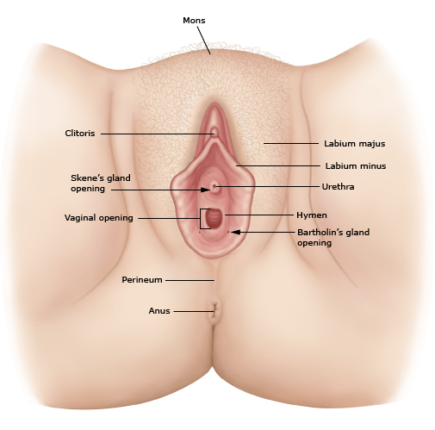
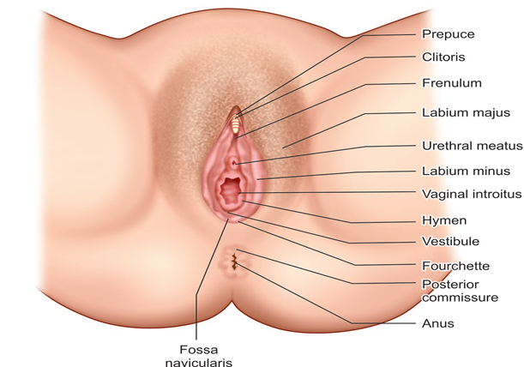

LABIA MINORA
- They are two thin folds of skin, devoid of fat, on either side just within the labia majora.
- Except in the parous women, they are exposed only when the labia majora are separated.
- Anteriorly, they divide to enclose the clitoris and unite with each other in front and behind the clitoris to form the prepuce and frenulum respectively.
- The lower portion of the labia minora fuses across the midline to form a fold of skin known as fourchette.
- It is usually lacerated during childbirth.
- Between the fourchette and the vaginal orifice is the fossa navicularis.
- The labia minora contain no hair follicles or sweat glands.
- The folds contain connective tissues, numerous sebaceous glands, erectile muscle fibers and numerous vessels and nerve endings.
- The labia minora are homologous to the penile urethra and part of the skin of penis in males.

CLITORIS
- · It is a small cylindrical erectile body, measuring about 1.5–2 cm situated in the most anterior part of the vulva.
- · It consists of a glans, a body and two crura.
- · The clitoris consists of two cylindrical corpora cavernosa (erectile tissue).
- · is richly supplied with nerves.
- · Clitoris is homologous to the penis in the male but it differs in being entirely separate from the urethra.
- · It is attached to the under surface of the symphysis pubis by the suspensory ligament.

VESTIBULE
- · The vestibule is the cleft between the labia minora.
- · It is a triangular space bounded anteriorly by the clitoris, posteriorly by the fourchette and on either side by labia minora.
- · There are four openings into the vestibule.
          - o Urethral opening
          - o Vaginal orifice and hymen
          - o Opening of Bartholin’s ducts
          - o Skene’s glands

a. Urethral opening
- · The opening is situated in the midline just in front of the vaginal orifice about 1–1.5 cm below the pubic arch.
- · The paraurethral ducts open either on the posterior wall of the urethral orifice or directly into the vestibule.

b. Vaginal orifice and hymen
- ü The vaginal orifice lies in the posterior end of the vestibule and is of varying size and shape.
- ü In virgins and nulliparae, the opening is closed by the labia minora, but in parous, it may be exposed.
- ü It is incompletely closed by a septum of mucous membrane, called hymen.
- ü The membrane varies in shape but is usually circular or crescentic in virgins.
- ü The hymen is usually ruptured at the consummation of marriage.
- ü During childbirth, the hymen is extremely lacerated and is later represented by cicatrized nodules of varying size, called the carunculae myrtiformes.
- ü On both sides it is lined by stratified squamous epithelium.
c. Opening of Bartholin’s ducts:
- · There are two Bartholin glands (greater vestibular gland), one on each side.
- · The vestibular bulbs are two oblong masses of erectile tissue that lie on either side of the vaginal entrance.
- · They contain a rich plexus of veins within the bulbospongiosus muscle.
- · They are homologous to the bulb of the penis and corpus spongiosum in the male.
- · Bartholin's glands, each about the size of a small pea, lie at the base of each bulb and open via a 2 cm duct into the vestibule between the hymen and the labia minora – outside the hymen at the junction of the anterior two-third and posterior one-third in the groove between the hymen and the labium minus.
- · They are pea-sized and yellowish white in color.
- · During sexual excitement, it secretes abundant alkaline mucus which helps in lubrication
- · Bartholin’s glands are homologous to the bulb of the penis in male.
d. Skene’s glands
- · are the largest paraurethral glands.
- · Skene’s glands are homologous to the prostate in the male.
- · The two Skene’s ducts may open in the vestibule on either side of the external urethral meatus.
hymen
- · is a thin fold of mucous membrane across the entrance to the vagina.
- · There are usually openings in it to allow menses to escape.
- · The hymen is partially ruptured during first coitus and is further disrupted during childbirth.
- · Any tags remaining after rupture are known as carunculae myrtiformes.

blood supply to VULVA
Arteries—
- Branches of internal pudendal artery—the chief being labial, transverse perineal, artery to the vestibular bulb and deep and dorsal arteries to the clitoris.
- Branches of femoral artery—superficial and deep external pudendal.
Veins—
- The veins form plexuses and drain into:
- Internal pudendal vein,
- vesical or vaginal venous plexus and
- · Long saphenous vein. Varicosities during pregnancy are not uncommon and may rupture spontaneously causing visible bleeding or hematoma formation.

NERVE SUPPLY
- · The supply is through bilateral spinal somatic nerves—
      - o anterosuperior part is supplied by the cutaneous branches from the ilioinguinal and genital branch of genitofemoral nerve (L1 and L2) and the
      - o posteroinferior part by the pudendal branches from the posterior cutaneous nerve of thigh (S1.2.3).
      - o Between these two groups, the vulva is supplied by the labial and perineal branches of the pudendal nerve (S2.3.4).
LYMPHATICS
- · Vulval lymphatics have bilateral drainage. Lymphatics drain into—
      - Ø Superficial inguinal nodes,
      - Ø intermediate groups of inguinal lymph nodes—gland of Cloquet and
      - Ø External and internal iliac lymph nodes.
Embryology of VULVA
- · External genitalia is developed in the region of the cranial aspect of ectodermal cloacal fossa;
- · clitoris from the genital tubercle;
- · labia minora from the genital folds;
- · labia majora from the labioscrotal swelling and
- · the vestibule from the urogenital sinus.

Age changes
- · In infancy the vulva is devoid of hair and there is considerable adipose tissue in the labia majora and pubis that is lost during childhood but reappears during puberty, at which time hair grows.
- · After menopause the skin atrophies and becomes thinner.
- · The labia minora shrink, subcutaneous fat is lost and the vaginal orifice becomes smaller.
INTERNAL GENITAL ORGANS
- · The internal genital organs in female include:
      - Ø vagina,
      - Ø uterus,
      - Ø fallopian tubes and
      - Ø the ovaries.
- · These organs are placed internally and require special instruments for inspection.
VAGINA
- The vagina is a fibromuscular canal lined with stratified squamous epithelium that leads from the uterus to the vulva.
- It constitutes the excretory channel for the uterine secretion and menstrual blood.
- It is the organ of copulation and forms the birth canal of parturition.
- The diameter of the canal is about 2.5 cm, being widest in the upper part and narrowest at its introitus.
- It has got enough power of distensibility.
- The canal is directed upwards and backwards forming an angle of 45° with the horizontal in erect posture.
- The long axis of the vagina almost lies parallel to the plane of the pelvic inlet and at right angles to that of the uterus.
VAGINAL WALL
- · Vagina has got an anterior, a posterior and two lateral walls.
- · The anterior and posterior walls are opposed together but the lateral walls are comparatively stiffer especially at its middle, as such, it looks “H” shaped on transverse section.
- · The length of the anterior wall is about 7 cm and that of the posterior wall is about 9 cm.
- · The vaginal walls are normally in apposition, except at the vault, where they are separated by the cervix.
- · The vault of the vagina is divided into four fornices: posterior, anterior and two lateral
FORNICES
- · The fornices are the clefts formed at the top of vagina (vault) due to the projection of the uterine cervix through the anterior vaginal wall where it is blended inseparably with its wall.
- · There are four fornices—
              - o one anterior,
              - o one posterior and
              - o two lateral;
- · The posterior one being deeper and the anterior, most shallow one.

VAGINA
- · The vaginal walls are rugose, with transverse folds.
- · The vagina is kept moist by secretions from the uterine and cervical glands and by some transudation from its epithelial lining.
- · It has no glands.
- · The epithelium is thick and rich in glycogen, which increases in the postovulatory phase of the cycle.
- · However, before puberty and after the menopause, the vagina is devoid of glycogen because of oestrogen deficiency.
- · Doderlein's bacillus is a normal commensal of the vagina that breaks down the glycogen to form lactic acid, producing a pH of around 4.5.
- · This has a protective role for the vagina in decreasing the growth of pathogenic organisms.

VAGINAL RELATIONS
Anterior—
- The upper one-third is related with base of the bladder and the lower two-thirds are with the urethra, the lower half of which is firmly embedded with its wall.
Posterior—
- The upper one-third is related with the pouch of Douglas,
- the middle-third with the anterior rectal wall separated by rectovaginal septum and
- the lower-third is separated from the anal canal by the perineal body

Lateral walls—
- The upper one-third is related with the pelvic cellular tissue at the base of broad ligament in which the ureter and the uterine artery lie approximately 2 cm from the lateral fornices.
- The middle third is blended with the levator ani and
- the lower-third is related with the bulbocavernosus muscles, vestibular bulbs and Bartholin’s glands
STRUCTURE OF VAGINA:
- · Layers from within outwards are—
- · mucous coat which is lined by stratified squamous epithelium without any secreting glands
- · submucous layer of loose areolar vascular tissues
- · muscular layer consisting of indistinct inner circular and outer longitudinal muscles and
- · Fibrous coat derived from the endopelvic fascia and is highly vascular.
VAGINAL SECRETION
- · The vaginal pH, from puberty to menopause, is acidic because of the presence of Döderlein’s bacilli which produce lactic acid from the glycogen present in the exfoliated cells.
- · The pH varies with the estrogenic activity and ranges between 4 and 5.
BLOOD SUPPLY TO VAGINA
- · The arteries involved are—
        - Cervicovaginal branch of the uterine artery,
        - Vaginal artery—a branch of anterior division of internal iliac or in common origin with the uterine,
        - Middle rectal and
        - internal pudendal. These anastomose with one another and form two azygos arteries— anterior and posterior.
- · Veins drain into internal iliac veins and internal pudendal veins.

LYMPHATICS TO VAGINA:
- · On each side, the lymphatics drain into—
      - o Upper one-third—internal iliac group,
      - o middle one-third up to hymen—internal iliac group,
      - o below the hymen—superficial inguinal group.

NERVE SUPPLY TO VAGINA:
- · The vagina is supplied by sympathetic and parasympathetic from the pelvic plexus.
- · The lower part is supplied by the pudendal nerve.
DEVELOPMENT
- · The vagina is developed from the following sources:
- · Upper 4/5th, above the hymen—the mucous membrane is derived from endoderm of the canalized sinovaginal bulbs. The musculature is developed from the mesoderm of two fused Müllerian ducts.
- · Lower 1/5th, below the hymen is developed from the endoderm of the urogenital sinus.
- · External vaginal orifice is formed from the genital fold ectoderm after rupture of the urogenital membrane.
Age changes
- · At birth, the vagina is under the influence of maternal oestrogens, so the epithelium is well developed.
- · After a couple of weeks, the effects of the oestrogens disappear and the pH rises to 7 and the epithelium atrophies.
- · At puberty the reverse occurs, and finally, at the menopause, the vagina tends to shrink and the epithelium atrophies.
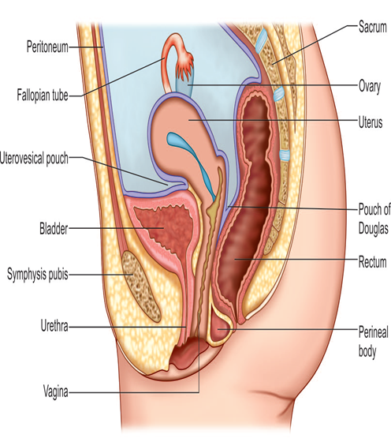
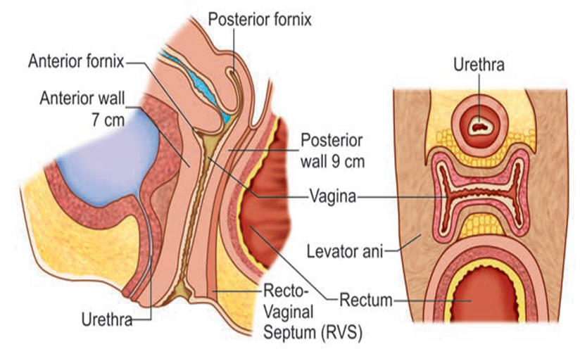

THE UTERUS
- The uterus is a hollow pyriform muscular organ situated in the pelvis between the bladder in front and the rectum behind.
- The uterus is shaped like an inverted pear, tapering inferiorly to the cervix, and in the non-pregnant state is situated entirely within the pelvis.
- It is hollow and has thick muscular walls. Its maximum external dimensions are approximately 7.5cm long, 5cm wide and 3cm thick
- An adult uterus weighs about 70 g.

POSITION OF UTERUS
- · The longitudinal axis of the uterus is, approximately, at right-angles to the vagina and normally tilts forwards.
- · This is termed anteversion.
- · The uterus is usually also flexed forwards on itself at the isthmus - anteflexion.
- · Its normal position is one of the anteversion and anteflexion.
- · In around 20 per cent of women, this tilt is not forwards but backwards - retroversion and retroflexion.
- · This does not have a pathological significance.
- · The uterus usually inclines to the right (dextrorotation) so that the cervix is directed to the left (levorotation) and comes in close relation with the left ureter.

MEASUREMENTS AND PARTS:
- · The uterus measures about 8 cm long, 5 cm wide at the fundus and its walls are about 1.25 cm thick.
- · Its weight varies from 50 gm to 80 gm.
- · It has got the following parts:
          - o Body or corpus
          - o Isthmus
          - o Cervix

Body or corpus of the uterus
- · The body is further divided into:
        - o fundus—the part which lies above the openings of the uterine tubes.
        - o The body proper is triangular and lies between the openings of the tubes and the isthmus.
- · The superolateral angles of the body of the uterus project outwards from the junction of the fundus and body and is called the cornua of the uterus.
- · The uterine tube, round ligament and ligament of the ovary are attached to it.
- · The area of insertion of each Fallopian tube is termed the cornu and the part of the body above the cornu, the fundus
Isthmus of the uterus
- · is a constricted part measuring about 0.5 cm, situated between the body and the cervix.
- · It is limited above by the anatomical internal os and below by the histological internal os (Aschoff).
- · Some consider isthmus as a part of the lower portion of the body of the uterus
cervix
- · Cervix is cylindrical in shape and measures about 2.5cm.
- · It extends from the isthmus and ends at the external os which opens into the vagina after perforating its anterior wall.
- · The part lying above the vagina is called supravaginal and that which lies within the vagina is called the vaginal part

CAVITY:
- · The cavity of the uterine body is triangular on coronal section with the base above and the apex below.
- · It measures about 3.5 cm.
- · There is no cavity in the fundus.
- · The cervical canal is fusiform and measures about 2.5 cm.
- · Thus, the normal length of the uterine cavity is usually 6.5–7 cm.

RELATIONS OF THE UTERUS
Anteriorly—
- · Above the internal os, the body forms the posterior wall of the uterovesical pouch.
- · Below the internal os, it is separated from the base of the bladder by loose areolar tissue.
Posteriorly—
- · It is covered with peritoneum and forms the anterior wall of the pouch of Douglas containing coils of intestine.
Laterally—
- · The double fold of peritoneum of the broad ligament are attached between which the uterine artery ascends up.
STRUCTURES - BODY
The wall consists of three layers from outside inwards:
- ü Parametrium: It is the serous coat which invests the entire organ except on the lateral borders. The peritoneum is intimately adherent to the underlying muscles.
- ü Myometrium: It consists of thick bundles of smooth muscle fibers held by connective tissues and are arranged in various directions. During pregnancy, however, three distinct layers can be identified—outer longitudinal, middle interlacing and the inner circular.
- ü Endometrium: The mucous lining of the cavity. As there is no submucous layer, the endometrium is directly opposed to the muscle coat. It consists of:
        - o lamina propria and
        - o surface epithelium.
- The surface epithelium is a single layer of ciliated columnar epithelium.
- The lamina propria contains stromal cells, endometrial glands, vessels and nerves. The glands penetrate the stroma and sometimes even enter the muscle coat.
- The endometrium is changed to decidua during pregnancy.
STRUCTURE-CERVIX
- · The cervix is composed mainly of fibrous connective tissues.
- · The smooth muscle fibers average 10–15%.
- · Only the posterior surface has got peritoneal coat.
- · Mucous coat lining the endocervix is simple non-ciliated columnar.
- · The vaginal part of the cervix is lined by stratified squamous epithelium.
- · The squamocolumnar junction is situated at the external os.
Uterine secretion
- · The endometrial secretion is scanty and watery.
- · Secretion of the cervical glands is alkaline and thick, rich in mucoprotein, fructose and sodium chloride.
BLOOD SUPPLY
· Arterial supply —
- o uterine arteries one on each side (anterior division of the internal iliac or in common with superior vesical artery.)
- o ovarian and vaginal arteries with which the uterine arteries anastomose.
- · The cervix is insensitive to touch, heat and also when it is grasped by any instrument. The uterus, too, is insensitive to handling and even to incision over its wall.

- Showing pattern of basal and spiral arteries in the endometrium;
(B) Internal blood supply of uterus
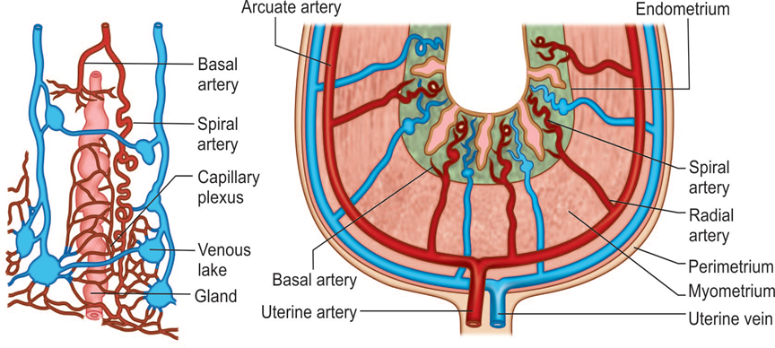
Age changes
- · The disappearance of maternal oestrogens after birth causes the uterus to decrease in length by around one-third and in weight by about one-half.
- · The cervix is then twice the length of the uterus.
- · At puberty, however, the corpus grows much faster and the size ratio reverses.
- · After the menopause, the uterus atrophies, the mucosa becomes very thin, the glands almost disappear and the wall becomes relatively less muscular.
- · These changes affect the cervix more than the corpus; cervical loops disappear and the external os becomes more or less flush with the vault.
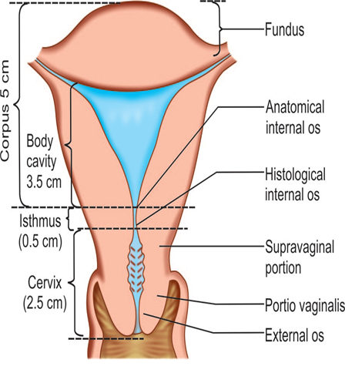
INTERNAL GENITALIA: FALLOPIAN TUBE & OVARIES
FALLOPIAN TUBE (Synonyms: Uterine tube, oviduct)
- · The uterine tubes are paired structures, measuring about 10 cm and are situated in the medial three-fourth of the upper free margin of the broad ligament.
- · Each tube has got two openings:
    - o one communicating with the lateral angle of the uterine cavity called uterine opening and measures 1 mm in diameter,
    - o the other is on the lateral end of the tube, called pelvic opening or abdominal ostium and measures about 2 mm in diameter

Parts of oviduct
· From medial to lateral are—
  - intramural or interstitial lying in the uterine wall and measures 1.25 cm in length and 1 mm in diameter,
  - isthmus—almost straight and measures about 3–4 cm in length and 2 mm in diameter,
  - ampulla—tortuous part and measures about 5 cm in length which ends in,
  - wide infundibulum measuring about 1.25 cm long with a maximum diameter of 6 mm.
    - o The abdominal ostium is surrounded by a number of radiating fimbriae (20–25), one of these is longer than the rest and is attached to the outer pole of the ovary called ovarian fimbria
The important functions of the tubes
· Transport of the gametes,
· To facilitate fertilization and survival of zygote through its secretion.

Blood Supply
· Arterial supply is from the uterine and ovarian.
· Venous drainage is through the pampiniform plexus into the ovarian veins.

THE OVARY
- · The ovaries are paired sex glands or gonads in female which are concerned for:
      - • germ cell maturation, storage and its release and
      - • steroidogenesis.
- •Each gland is oval in shape and pinkish gray in color and the surface is scarred during reproductive period.
- •It measures about 3 cm in length, 2 cm in breadth and 1 cm in thickness.
- •Each ovary presents:
- •two ends—tubal and uterine,
- •two borders—mesovarium and free posterior and
- •two surfaces—medial and lateral.
- · The ovary is the only intra-abdominal structure not to be covered by peritoneum
- · it lies in the ovarian fossa on the lateral pelvic wall.
- · it is attached to the posterior layer of the broad ligament by the mesovarium, to the lateral pelvic wall by the infundibulopelvic ligament and to the uterus by the ovarian ligament.

RELATIONS
· Mesovarium or anterior border
  - o A fold of peritoneum from the posterior leaf of the broad ligament is attached to the anterior border through which the ovarian vessels and nerves enter the hilum of the gland.
· Posterior border
o is free and is related to the tubal ampulla. It is separated by the peritoneum from the ureter and the internal iliac artery.
· Medial surface
  - o is related to fimbrial part of the tube.
· Lateral surface
  - o is in contact with the ovarian fossa on the lateral pelvic wall.
STRUCTURES:
•The ovary is covered by a single layer of cubical cell known as germinal epithelium.
•The substance of the gland consists of:
  - a. outer cortex and
  - b. inner medulla.
Cortex of the ovary
- · It consists of stromal cells which are thickened beneath the germinal epithelium to form tunica albuginea.
- · During reproductive period the cortex is studded with numerous follicular structures, called the functional units of the ovary, in various phases of their development which include:
  - primordial follicles,
  - maturing follicles,
  - Graafian follicles and
  - corpus luteum.
· Atresia of the structures results in formation of atretic follicles or corpus albicans.
· These are related to sex hormone production and ovulation
Medulla of the ovary
· It consists of loose connective tissues, few unstriped muscles, blood vessels and nerves.
· There is a small collection of cells called “hilus cells” which are homologous to the interstitial cells of the testes.
Blood supply
· Arterial supply – ovarian artery, a branch of the abdominal aorta.
· Venous drainage – pampiniform plexus.
· NERVE SUPPLY: Sympathetic supply comes down along the ovarian artery from T10 segment. Ovaries are sensitive to manual squeezing.
DEVELOPMENT:
· The ovary is developed from the cortex of the undifferentiated genital ridges by about 9th week; the primary germ cells reaching the site migrating from the dorsal end of yolk sac.
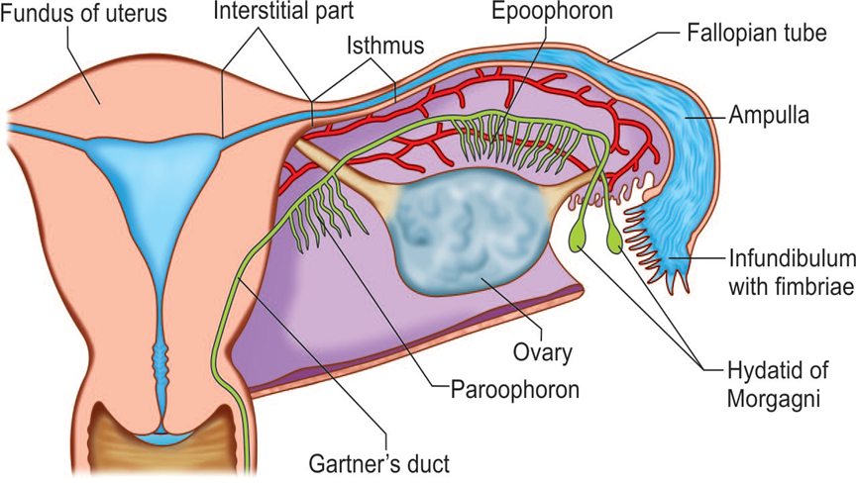
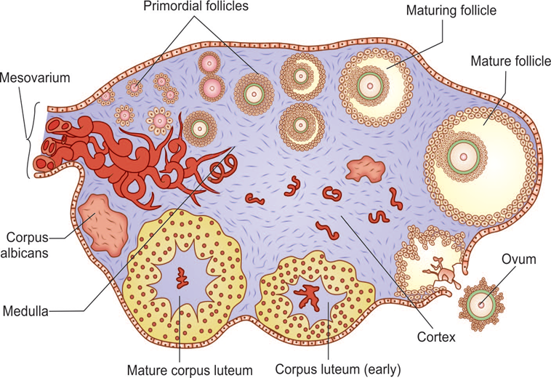
PELVIC FLOOR (Synonym: Pelvic diaphragm)
· Pelvic floor is a muscular partition which separates the pelvic cavity from the anatomical perineum.
· It consists of three sets of muscles on either side—
o pubococcygeus,
o iliococcygeus and
o Ischiococcygeus
- · these are collectively called levator ani.
- · Its upper surface is concave and slopes downwards, backwards and medially and is covered by parietal layer of pelvic fascia.
- · The inferior surface is convex and is covered by anal fascia.
- · The muscle with the covering fascia is called the pelvic diaphragm.
Levator ani muscles viewed from above

Levator ani muscle
· ORIGIN:
o Each levator ani arises from the back of the pubic rami, from the condensed fascia covering the obturator internus (white line) and from the inner surface of the ischial spine.
· INSERTION:
o From this extensive origin, the fibers pass, backwards and medially to be inserted in the midline from before backwards to the vagina (lateral and posterior walls), perineal body and anococcygeal raphe, lateral borders of the coccyx and lower part of the sacrum

GAPS ON PELVIC FLOOR
· There are two gaps in the midline—
    - • The anterior one is called hiatus urogenitalis which is bridged by the muscles and fascia of urogenital triangle and pierced by the urethra and vagina.
    - • The posterior one is called hiatus rectalis, transmitting the rectum.

STRUCTURES IN RELATION TO PELVIC FLOOR
The superior surface is related with the following:
- • Pelvic organs from anterior to posterior are bladder, vagina, uterus and rectum.
- • Pelvic cellular tissues between the pelvic peritoneum and upper surface of the levator ani which fill all the available spaces.
- • Ureter lies on the floor in relation to the lateral vaginal fornix. The uterine artery lies above and the vaginal artery lies below it.
- • Pelvic nerves.
- · The inferior surface is related to the anatomical perineum.

FUNCTIONS OF THE PELVIC FLOOR
- · To support the pelvic organs—The pubovaginalis which forms a “U” shaped sling, supports the vagina which in turn supports the other pelvic organs— bladder and uterus. Weakness or tear of this sling during parturition is responsible for prolapse of the organs concerned.
- · To maintain intra-abdominal pressure by reflexly responding to its changes.
- · Facilitates anterior internal rotation of the presenting part when it presses on the pelvic floor.
- · Puborectalis plays an ancillary role to the action of the external anal sphincter.
- · Ischiococcygeus helps to stabilize the sacroiliac and sacrococcygeal joints.
- · To steady the perineal body.

PELVIC FLOOR DURING PREGNANCY AND PARTURITION
· During pregnancy
- o levator muscles undergo hypertrophy, become less rigid and more distensible. Due to water retention, it swells up and sags down.
· In the second stage,
- o the pubovaginalis and puborectalis relax and the levator ani is drawn up over the advancing presenting part in the second stage.
- o Failure of the levator ani to relax at the crucial moment may lead to extensive damage of the pelvic structures
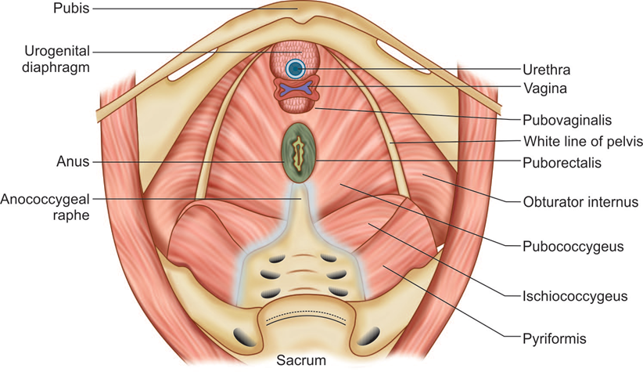

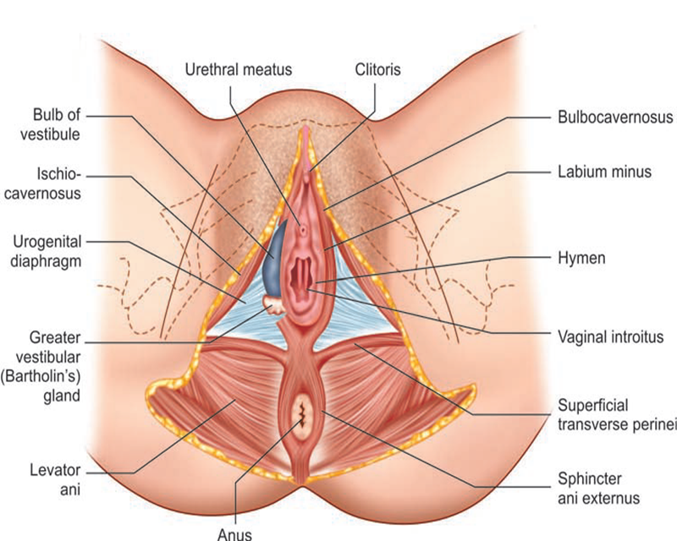

PERINEUM
ANATOMICAL PERINEUM
· It is bounded above by:
o inferior surface of the pelvic floor,
o below by the skin between the buttocks and thighs.
o Laterally by the ischiopubic ramus, ischial tuberosities and sacrotuberous ligaments and
o posteriorly, by the coccyx.
· The diamond shaped space of the bony pelvic outlet is divided into two triangular spaces with the common base formed by the free border of the urogenital diaphragm.
o The anterior triangle is called the urogenital triangle which fills up the gap of the hiatus urogenitalis and is important from the obstetric point of view.
  - o The posterior one is called the anal triangle

Urogenital Triangle
- · It is pierced by the terminal part of the vagina and the urethra.
- · Has superficial and deep perineal pouch compartments.
- · The superficial pouch is formed by the deep layer of the superficial perineal fascia (Colles fascia) and inferior layer of the urogenital diaphragm (perineal membrane
- · The deep perineal pouch is formed by the inferior and superior layer of the urogenital diaphragm—together called urogenital diaphragm or triangular ligament
Anal Triangle
- · The triangle has got no obstetric importance.
- · It contains the terminal part of the anal canal with sphincter ani externus, anococcygeal body, ischiorectal fossa, blood vessels, nerves, and lymphatics.

OBSTETRICAL PERINEUM:(Synonyms: Perineal body, central point of the perineum)
- · The pyramidal shaped tissue where the pelvic floor and the perineal muscles and fascia meet in between the vagina and the anal canal is called the obstetrical perineum.
- · It measures about 4 cm × 4 cm with the base covered by the perineal skin and the apex is pointed and is continuous with the rectovaginal septum.

Importance of obstetric perineum
• It helps to support the levator ani which is placed above it.
• By supporting the posterior vaginal wall, it indirectly supports the anterior vaginal wall, bladder and the uterus.
• It is vulnerable to injury during childbirth.
• Deliberate cutting of the structures during delivery is called episiotomy.
PELVIC CELLULAR TISSUE
• It lies between the pelvic peritoneum and the pelvic floor and fills up all the available empty spaces.
• It contains fatty and connective tissues and unstriated muscle fibers.
• Its distribution around the vaginal vault, supravaginal part of the cervix and into the layers of the broad ligament is called parametrium.
Importance of the pelvic cellular tissue
• To support the pelvic organs.
• To form protective sheath for the blood vessels and the terminal part of the ureter.
• infection spreads along the track, so formed, outside the pelvis to the perinephric region along the ureter, to the buttock along the gluteal vessels, to the thigh along the external iliac vessels and to the groin along the round ligament.
• Marked hypertrophy occurs during pregnancy to widen up the spaces.

POUCH OF DOUGLAS
• This is a narrow peritoneal cul-de-sac in the pelvis situated in the rectouterine space.
• It is continuous with the pararectal fossa of either side.

Contents of Pouch of Douglas:
o It may remain empty but may contain coils of intestine or omentum.

Relations of POUCH OF DOUGLAS
• Anteriorly,
o it is bounded by the peritoneal covering of the cervix, posterior vaginal fornix and upper-third of the posterior vaginal wall.
• Posteriorly,
o it is bounded by the peritoneal covering on the anterior surface of the rectum.
• Laterally,
o it is limited by the uterosacral folds of peritoneum covering the uterosacral ligaments.
• The floor
o is formed by the reflection of the anterior peritoneum onto the anterior surface of the rectum. It is about 6–7 cm above the anal orifice. Below the floor, there is a thin fibrous tissue septum (rectovaginal).

Surgical Importance of Pouch of Douglas
• As it is the most dependent part of the peritoneal cavity, intraperitoneal blood or pus usually settles down to the pouch to produce either pelvic hematocele or pelvic abscess.
• Herniation of the pouch through the posterior fornix may occur producing the clinical entity of enterocele.
• Vaginal ligation is done through opening the pouch.
• Culdoscopy, culdocentesis or at time pneumoperitoneum may be done through the pouch.
• Nodules deposited in the pouch can help in the clinical diagnosis of pelvic malignancy, endometriosis or genital tuberculosis.
Uterine Support
BROAD LIGAMENT
• The double fold of peritoneum which extends from the lateral border of the uterus to the lateral pelvic wall of pelvis is called broad ligament.
• These, truly are not ligaments
BROAD LIGAMENT
• consists of two layers, anterior and posterior.
• The layers are continuous at its upper free border embracing the Fallopian tube.
• The lower part of the broad ligament is wider from before backwards and the layers are reflected above the pelvic diaphragm.

PARTS OF BROAD LIGAMENT
1. Infundibulopelvic Ligament (Syn: Suspensory ligament of the ovary):
• It includes the portion of the broad ligament which extends from the infundibulum to the lateral pelvic wall.
• It contains ovarian vessels and nerves and lymphatics from the ovary, Fallopian tube and body of the uterus.
2. Mesovarium:
• The ovary is attached to the posterior layer of the broad ligament by a fold of peritoneum called mesovarium (ovarian mesentery).
• Through this fold, ovarian vessels, nerves and lymphatics enter and leave the hilum.
• The ovary is not enclosed within the broad ligament
3. Mesosalpinx:
• The part of the broad ligament between the fallopian tube and the level of attachment of the ovary is the mesosalpinx.
• It contains utero-ovarian anastomotic vessels and vestigial remnants.
4. Mesometrium:
  - • The part of the broad ligament below the mesosalpinx is called mesometrium.
  - • It is the longest portion which is related with the lateral border of the uterus.

contents of the broad ligament
• Fallopian tube.
• Uterine and ovarian arteries with their branches, including the anastomotic branches between them and corresponding veins.
• Nerves and lymphatics from the uterus, Fallopian tube and ovary.
• Proximal part of the round ligament which raises a peritoneal fold on the anterior leaf.
• Ovarian ligament which raises a peritoneal fold on the posterior leaf.
• Parametrium containing loose areolar tissue and fat. The terminal part of the ureter, uterine artery, paracervical nerve and lymphatic plexus are lying at the base of the broad ligament.
• Vestigial structures, such as duct of Gartner, epoophoron, and paroophoron.
MACKENRODT’S LIGAMENTS (SYN: CARDINAL LIGAMENT, TRANSVERSE CERVICAL)
• Origin:
o Condensation of parietal fascia covering the obturator internus.
• Insertion:
o Lateral supravaginal cervix and upper part of lateral vaginal wall in a fan-shaped manner. This insertion is continuous with the endopelvic and paricervical fascial ring
Function:
• Lateral stabilization to the cervix at the level of ischial spine.
o Primary vascular conduits of the uterus and vagina
UTEROSACRAL LIGAMENTS
• Origin:
o Periosteum of sacral vertebra 2, 3 and 4.
• Insertion:
o Posterolateral surface of the cervix at the level of internal os
• Content:
o Uterosacral plexus of autonomic nerves. Smooth muscle and minimal vessels.
• Function:
o These are the primary proximal suspensory ligaments of the uterovaginal complex.
o They hold the cervix posteriorly at the level of the ischial spines.
o Uterus is thus maintained anteflexed and the vagina is suspended over the levator plate.

ROUND LIGAMENTS
- • Each measures about 10–12 cm.
- • It is attached at the cornu of the uterus below and in front of the fallopian tube.
- • It courses beneath the anterior leaf of the broad ligament to reach the internal abdominal ring.
- • After traversing through the inguinal canal, it fuses with the subcutaneous tissue of the anterior third of the labium majus.
- • It contains plain muscles and connective tissue.

OVARIAN LIGAMENTS
- • These are paired, one on each side.
- • Each one is a fibromuscular cord-like structure which attaches to the inner pole of the ovary and to the cornu of the uterus posteriorly below the level of the attachment of the fallopian tube
- • Morphologically, it is continuous with the round ligament.

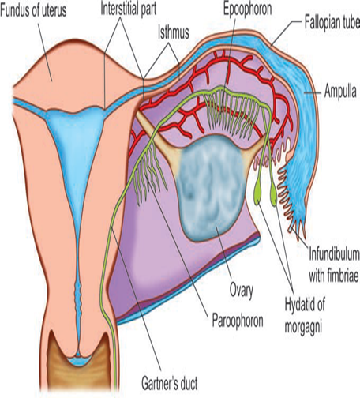
URINARY SYSTEM AND BREAST
FEMALE URETHRA
• The female urethra extends from the neck of the bladder to the external urethral meatus which opens into the vestibule about 2.5 cm below the clitoris.
• It measures about 4 cm and has a diameter of 6 mm.
• Its upper half is separated from the anterior vaginal wall by loose areolar tissue and the lower half is firmly embedded in its wall.
• Numerous tubular glands called paraurethral glands open into the lumen through ducts eg Skene’s ducts which open either on the posterior wall or into the vestibule.
• These glands are the sites for harboring infection and occasional development of benign adenoma or malignant changes.
THE URINARY BLADDER
• The bladder is a hollow muscular organ with considerable power of distension.
• Its capacity is about 450mL but can retain as much as 3–4 liters of urine.
• When distended it is ovoid in shape. It has got:
- o an apex
- o superior surface
- o Base
- o two inferolateral surfaces and
- o neck, which is continuous with the urethra.
• The base and the neck remain fixed even when the bladder is distended.
THE BREAST
• The breasts are large, modified sebaceous glands.
• The breasts are bilateral and in female constitute accessory reproductive organs as the glands are concerned with lactation following childbirth.
• The shape of the breast varies in women and also in different periods of life.
• But the size of the base of the breast is fairly constant.
• It usually extends from the second to sixth rib in the midclavicular line.
• It lies in the subcutaneous tissue over the fascia covering the pectoralis major or even beyond that to lie over the serratus anterior and external oblique.
• A lateral projection of the breast towards the axilla is known as axillary tail of Spence.
• It lies in the axillary fossa, sometimes deep to the deep fascia.
• The breast weighs 200–300 gm during the childbearing age.
NB
G-spot
• The G-spot, also called the Gräfenberg spot (for German gynecologist Ernst Gräfenberg, is characterized as an erogenous area of the vagina that, when stimulated, may lead to strong sexual arousal, powerful orgasms and potential female ejaculation.
• It is typically reported to be located 5–8 cm up the front (anterior) vaginal wall between the vaginal opening and the urethra and is a sensitive area that may be part of the female prostate.
• The existence of the G-spot has not been proven, nor has the source of female ejaculation.
• Although the G-spot has been studied since the 1940s, disagreement persists over its existence as a distinct structure, definition and location.
• A 2009 British study concluded that its existence is unproven and subjective, based on questionnaires and personal experience.
• Other studies, using ultrasound, have found physiological evidence of the G-spot in women who report having orgasms during vaginal intercourse
It is also hypothesized that the G-spot is an extension of the clitoris and that this is the cause of orgasms experienced vaginally.
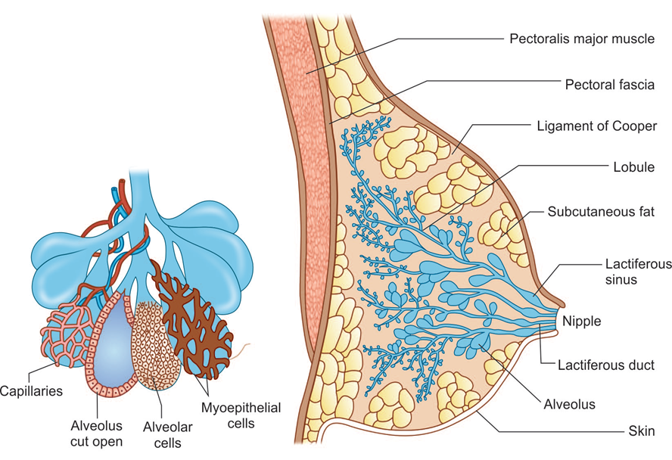
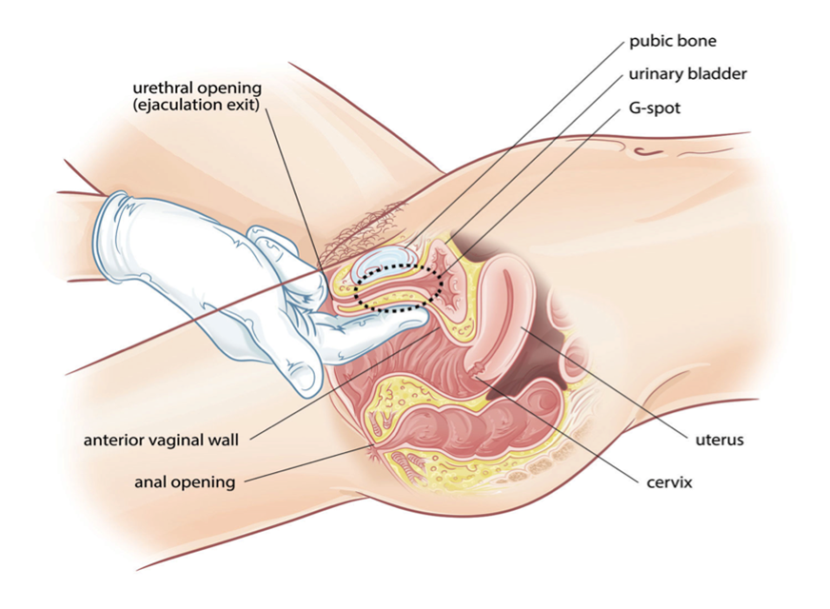
Summary
•Knowledge of the anatomy of female and male reproductive systems is essential in clinical assessment, counseling, patient and community education, as well as in diagnosis and treatment of obstetric and gynaecological conditions.

THE MALE REPRODUCTIVE SYSTEM
• The reproductive system in men has components in the abdomen, pelvis, and perineum
• The major components are a testis, epididymis, ductus deferens, and ejaculatory duct on each side, and the urethra and penis in the midline.
• Three types of accessory glands are associated with the system:
o A single prostate;
o A pair of seminal vesicles;
o A pair of bulbourethral
o glands.
The scrotum
• The scrotum is an outpouching of the lower part of the anterior abdominal wall.
• It contains the testes, the epididymis’s, and the lower ends of the spermatic cords.
• It is divided on its surface into two compartments by a raphé, which is continued forward to the under surface of the penis, and
• backward, along the middle line of the perineum to the anus.
• Each compartment contains one of the two testes, and one of the epididymides.
• The wall of the scrotum has the following layers:

o Skin
o Superficial fascia
o Spermatic fasciae
o Tunica vaginalis
Skin
- • The skin of the scrotum is thin, wrinkled, and pigmented and forms a single pouch. A slightly raised ridge in the midline indicates the line of fusion of the two lateral labioscrotal swellings.

Superficial fascia
• This is continuous with the fatty and membranous layers of the anterior abdominal wall.
• The fat is replaced by smooth muscle called the dartos muscle.
• This is innervated by sympathetic nerve fibers and is responsible for the wrinkling of the overlying skin.

Spermatic fasciae
• It has three layers which lie beneath the superficial fascia and are derived from the three layers of the anterior abdominal wall on each side.
• The external spermatic fascia is derived from the aponeurosis of the external oblique muscle; the cremasteric fascia is derived from the internal oblique muscle; and, finally, the internal spermatic fascia is derived from the fascia transversalis.

Tunica vaginalis
• This lies within the spermatic fasciae and covers the anterior, medial, and lateral surfaces of each testis.
Lymph from the skin and fascia, including the tunica vaginalis, drains into the superficial inguinal lymph nodes
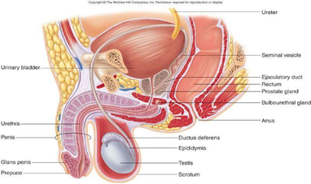
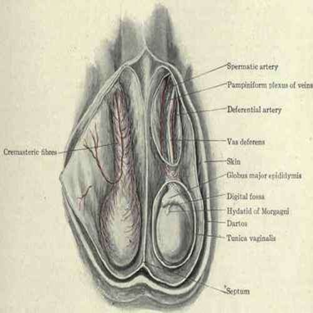

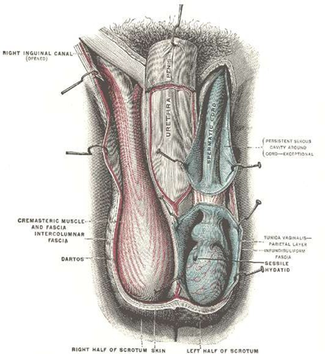
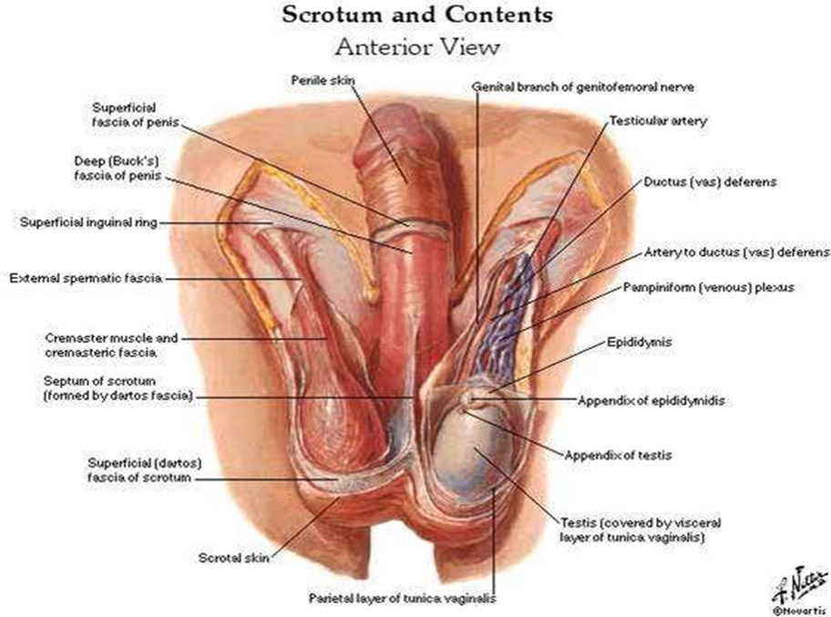
TESTES

- • Testis has ellipsoid- shaped.
- • Testes develop in the abdomen and move before birth into the scrotum.
- • The left testis usually lies at a lower level than the right.
- • The testis are covered by:
    - o A closed sac of peritoneum (the tunica vaginalis), which originally connected to the abdominal cavity. Normally after testicular descent, the connection closes, leaving a fibrous remnant.
    - o It is covered by a fibrous capsule called the tunica albuginea.
- • In the inner surface of the capsule is a series of fibrous septa that divide the interior of the organ into lobules.
- • Lying within each lobule are 1 to 3 coiled seminiferous tubules.
- • The tubules open into a network of channels called the rete testis.
- • Small efferent ductules connect the rete testis to the upper end of the epididymis.

Epididymis
• The epididymis is a single, long coiled duct that courses along the posterolateral side of the testis.
• The tunica vaginalis covers the epididymis with the exception of the posterior border.
• Structurally, epididymis divided into:
o Head
o Body
o tail
Epididymis

It has two distinct components:
• The efferent ductules, which form an enlarged coiled mass that sits on the posterior superior pole of the testis and forms the head of the epididymis;
• The true epididymis, which is a single, long coiled duct into which the efferent ductules all drain, and which continues inferiorly along the posterolateral margin of the testis as the body of epididymis and enlarges to form the tail of epididymis at the inferior pole of the testis.
• The testicular artery is a branch of the abdominal aorta.
Venous drainage of the Testis and Epididymis
• The testicular veins emerge from the testis and the epididymis as a venous network, the pampiniform plexus.
• This becomes reduced to a single vein as it ascends through the inguinal canal.
• The right testicular vein drains into the inferior vena cava, and the left vein joins the left renal vein.
• Lymphatic drainage of the testes is to the para- aortic lymph nodes
Ductus deferens
• (Latin: "carrying-away vessel"), also called vas deferens.
• The ductus deferens is a long muscular duct that transports spermatozoa from the tail of the epididymis to the ejaculatory duct
• The vas arises from the tail of the epididymis and traverses the inguinal canal to the deep ring, passes downwards on the lateral wall of the pelvis almost to the ischial tuberosity and turns medially to cross the ureter posterior to the bladder.
• It continues inferomedially along the base of the bladder, anterior to the rectum, almost to the midline, where it is joined by the duct of the seminal vesicle to form the ejaculatory duct.
• The terminal part of the vas deferens is dilated to form the ampulla of the vas deferens.
• The ejaculatory duct penetrates through the prostate gland to connect with the prostatic urethra.
Seminal vesicle
• The seminal vesicles are an accessory gland of the male reproductive system.
• The seminal vesicles are two lobulated organs about 2 in. (5 cm) long lying on the posterior surface of the bladder
• On the medial side of each vesicle lies the terminal part of the vas deferens.
• Posteriorly, the seminal vesicles are related to the rectum.
• Inferiorly, each seminal vesicle narrows and joins the vas deferens of the same side to form the ejaculatory duct.
• Arteries
o The arterial blood supply from, the inferior vesicle and middle rectal arteries
• Veins
o The veins drain into the internal iliac veins.
Ejaculatory Ducts
• The two ejaculatory ducts are each less than 1 in. (2.5 cm) long and are formed by the union of the vas deferens and the duct of the seminal vesicle.
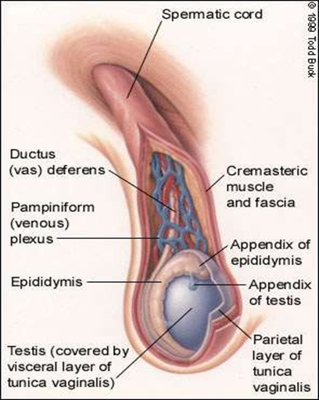
• The ejaculatory ducts pierce the posterior surface of the prostate and open into the prostatic part of the urethra, close to the margins of the prostatic utricle; their function is to drain the seminal fluid into the prostatic urethra. 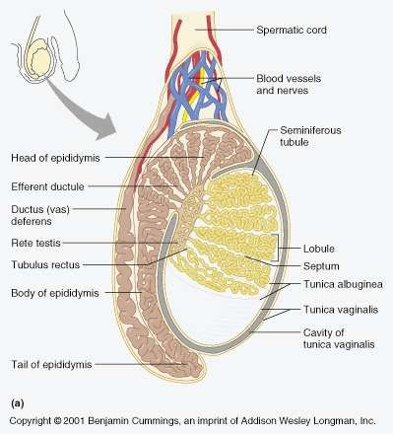

Prostate
• The prostate is an unpaired accessory structure of the male reproductive system that surrounds the urethra in the pelvic cavity.
• It lies immediately inferior to the bladder, above the urogenital diaphragm, posterior to the pubic symphysis, and anterior to the rectum.
• The prostate is shaped like an inverted rounded cone with a larger base, which is continuous above with the neck of the bladder, and a narrower apex, which rests below on the pelvic floor.
• The inferolateral surfaces of the prostate are in contact with the levator ani muscles that together cradle the prostate between them.
• The two ejaculatory ducts pierce the upper part of the posterior surface of the prostate to open into the prostatic urethra at the lateral margins of the prostatic utricle.
Relations of Prostate
• Superiorly
o The base of the prostate is continuous with the neck of the bladder.
o The urethra enters the center of the base of the prostate.
• Inferiorly
o The apex of the prostate lies on the upper surface of the urogenital diaphragm.
o The urethra leaves the prostate just above the apex on the anterior surface
• Anteriorly
o The prostate is related to the symphysis pubis.
o The prostate is connected to the posterior aspect of the pubic bones by the puboprostatic ligaments.
• Laterally
o The prostate is embraced by the anterior fibers of the levator ani.
• Posteriorly
o The prostate is closely related to the anterior surface of the rectal ampulla and is separated from it by the rectovesical septum (fascia of Denonvilliers).
Structure of the Prostate
• Enclosed within thin dense fibrous capsule
• Inner loose sheath derived from pelvic fascia – “prostatic sheath”
– Continuous inferiorly with superior fascia of urogenital diaphragm
– Posteriorly it is part of rectovesical septum
– Separates bladder, seminal vesicles and prostate from rectum
• Prostatic venous plexus lies between fibrous capsule and prostatic sheath.
Prostate divided into:
– Two lateral lobes
– One median lobe
– Anterior and posterior lobes

Structure of the Prostate
• Anterior
– Tissue lying anterior to urethra
– No glands; fibromuscular tissue only
• Median
– Cone-shaped region between ejaculatory ducts and urethra
• Lateral (left & right)
– Main mass of gland, continuous posteriorly
– Separated by prostatic urethra
• Posterior
– Describes postero-medial part of lateral lobes palpable through rectum on DRE.

Blood Supply of The Prostate
• Arterial supply
– Arteries derived from internal pudenal, inferior vesical and middle rectal arteries (branches of internal iliac)
• Venous drainage
– Veins form prostatic venous plexus around sides and base of prostate – located between capsule and sheath
– Drains into internal iliac veins
– Also communicates with vesical venous plexus and vertebral venous plexuses.

Lymphatics and innervation of The Prostate
o Lymphatic drainage
§ Lymph vessels terminate in internal iliac and sacral lymph nodes
§ Some vessels from posterior surface pass with lymph vessels from bladder to external iliac LN’s
o Innervation
§ Parasympathetic fibres arise from pelvic splanchnic nerves
§ Sympathetic fibres from inferior hypogastric plexuses
PENIS
• The penis is a pendulous organ suspended from the front and sides of the pubic arch and containing the greater part of the urethra.
• It consists of internal root, external shaft, & glans.
• Root: the portion of the penis that extends internally into the pelvic cavity.
• Shaft: the length of the penis between the glans and the body.
• Glans: the head of the penis; has many nerve endings.
• Foreskin: a covering of skin over the penile glans.
• The root of penis consists of the two crura, which are proximal parts of the corpora cavernosa attached to the pubic arch, and the bulb of penis, which is the proximal part of the corpus spongiosum anchored to the perineal membrane.
• The body of the penis is essentially composed of three cylinders of erectile tissue enclosed in a tubular sheath of fascia (Buck's fascia).
• The erectile tissue is made up of two dorsally placed corpora cavernosa and a single corpus spongiosum applied to their ventral surface.
• At its distal extremity, the corpus spongiosum expands to form the glans penis, which covers the distal ends of the corpora cavernosa.
• On the tip of the glans penis is the slit like orifice of the urethra, called the external urethral meatus.
External penile structures
• Corona: the rim of the penile glans.
• Frenulum: thin strip of skin connecting the glans to the shaft on the underside of the penis.
• Both are highly sensitive areas to the touch

Blood Supply of The Penis
Arteries
• The corpora cavernosa is supplied by the deep arteries of the penis; the corpus spongiosum is supplied by the artery of the bulb.
• In addition, there is the dorsal artery of the penis.
• All the above arteries are branches of the internal pudendal artery.
Veins
• The veins drain into the internal pudendal veins.
Lymphatics and innervation of The Penis
Lymph Drainage
• The skin of the penis is drained into the medial group of superficial inguinal nodes.
• The deep structures of the penis are drained into the internal iliac nodes
Nerve Supply
• Sensation
• The nerve supply is from the pudendal nerve and the pelvic plexuses.
• Erectile function
• Parasympathetic(excitatory)
Sympathetic (inhibitory)
Summary
Penis Nerve Supply
• Sensation
• The nerve supply is from the pudendal nerve and the pelvic plexuses.
• Erectile function
• Parasympathetic (excitatory)
  - Sympathetic (inhibitory)

